Lab #03
Md Ashraf
October 20, 2024
Introduction:
In this lab, we process a single shot gather and CMP gather using essential seismic data enhancement techniques. These include amplitude correction (gain) to balance energy attenuation, frequency-based filtering (band-pass) to remove noise, F/K filtering (fan filter) to isolate wave modes, and velocity analysis to determine subsurface velocities. These steps collectively enhance data quality for precise subsurface interpretation.
Results and Interpretation:
- Amplitude Correction (Gain):
There are a few methods such as ‘t to the power p’, ‘Automatic Gain Control’ methods which can be used to apply gain to the seismic data to correct for the attenuation in the amplitude due to ‘geometrical spreading’ and ‘inelastic attenuation’. Here we have tried to apply different gain methods with varying parameters to understand how does these methods work in reality.
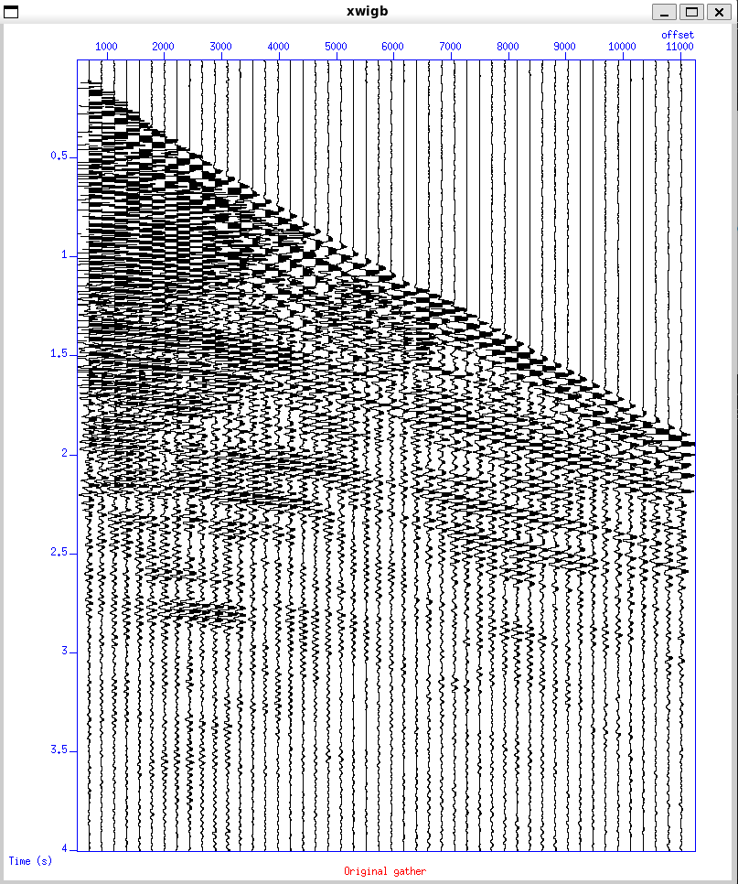 | 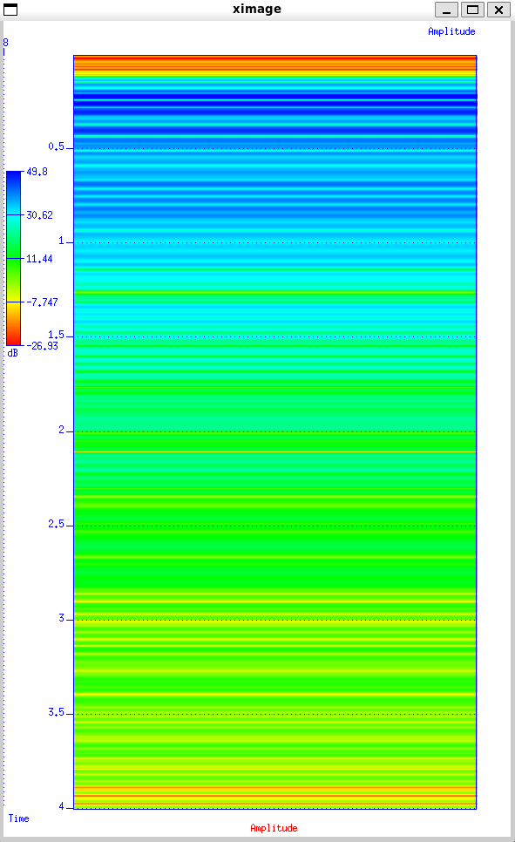 | 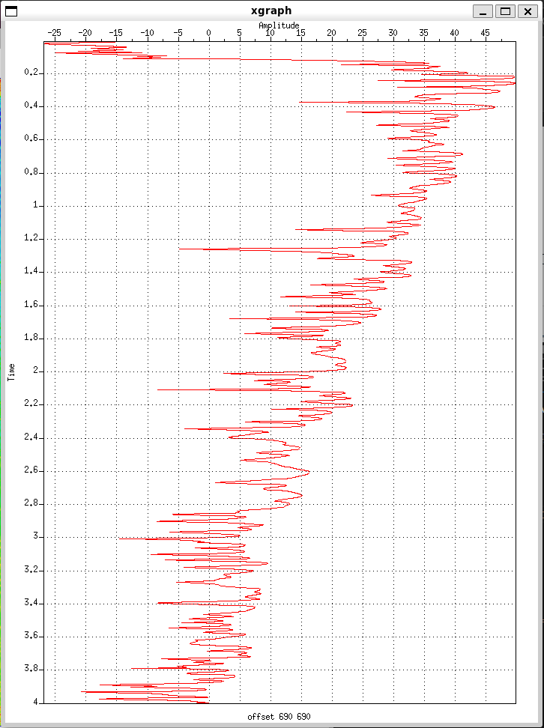
Fig. 1 – Wiggle Plot of seismic Data | Fig. 2 – Attenuation of amplitude with time colormap diagram | Fig. 3 – Attenuation of amplitude with time line plot
After application of AGC (Automatic Gain Control) having time window t = 0.750 s, the amplified results are shown below:
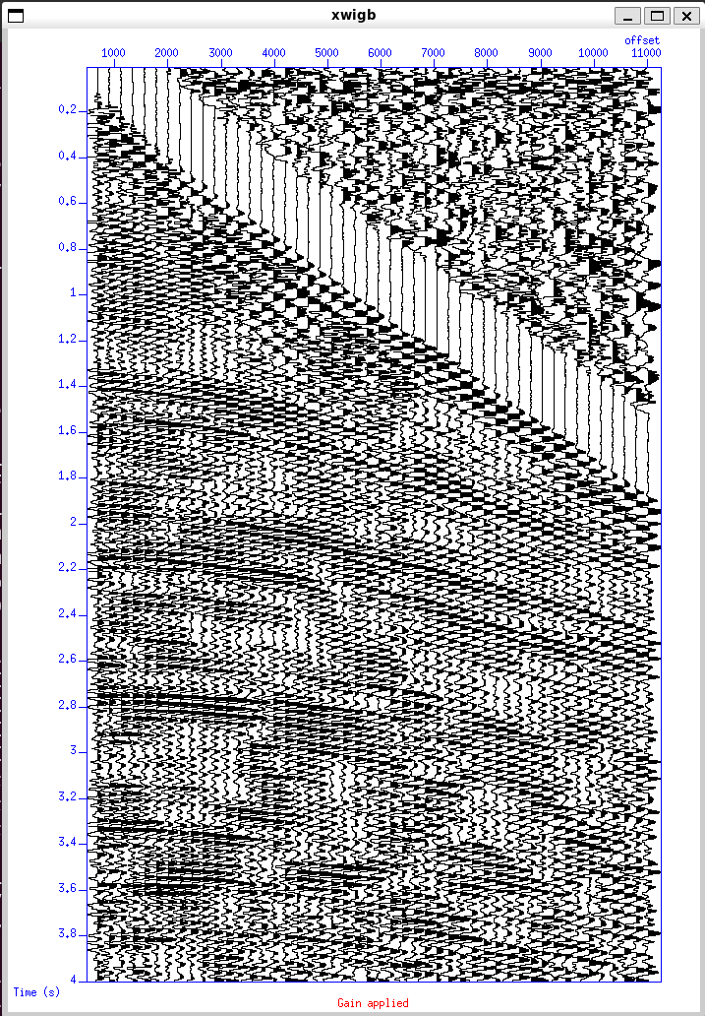 | 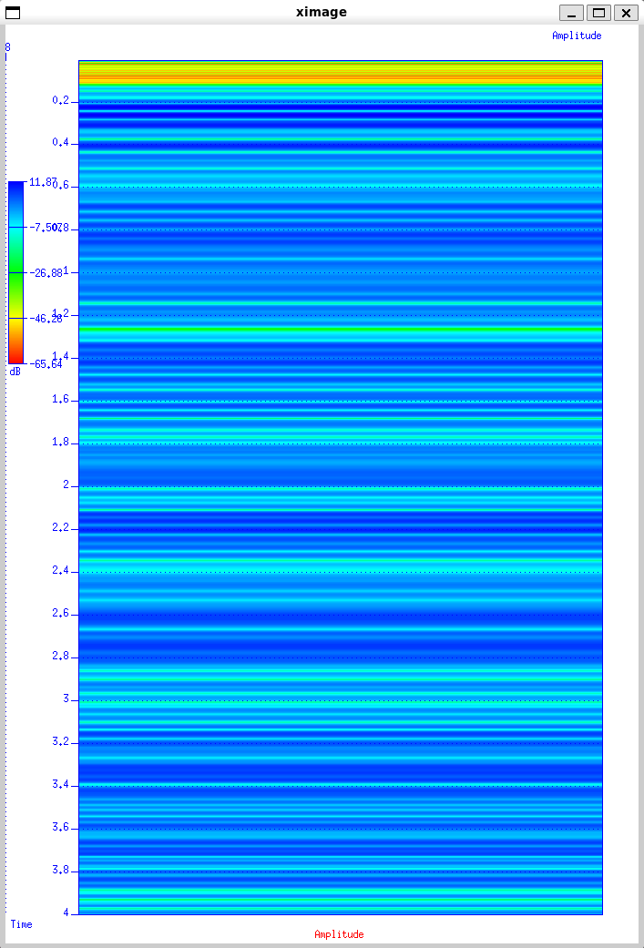 | 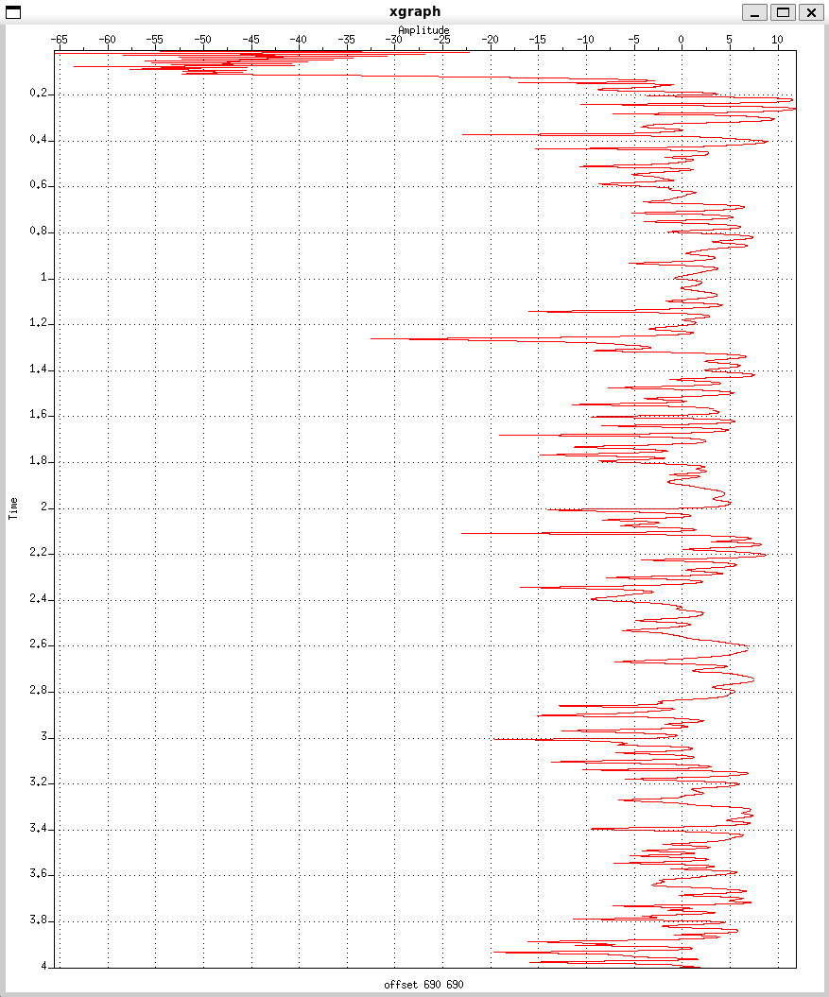
Fig. 4 – Wiggle Plot of seismic Data after AGC(0.750 s) | Fig. 5 – Attenuation of amplitude with time colormap diagram after AGC (0.750 s) | Fig. 6 – Attenuation of amplitude with time line plot after AGC (0.750 s)
On top of the AGC we have applied a t^{p} correction with the p value of 1.5, the obtained results are shown below:
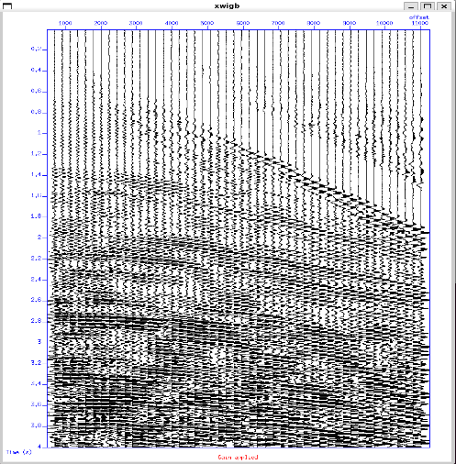 | 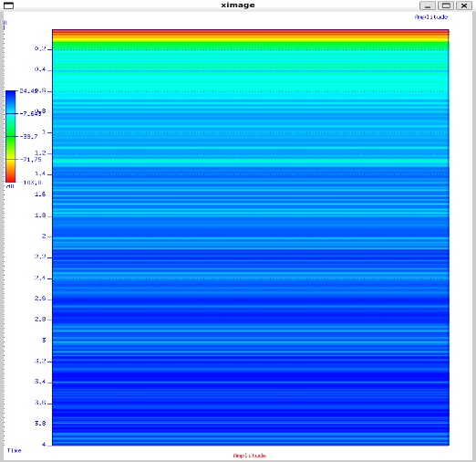 | 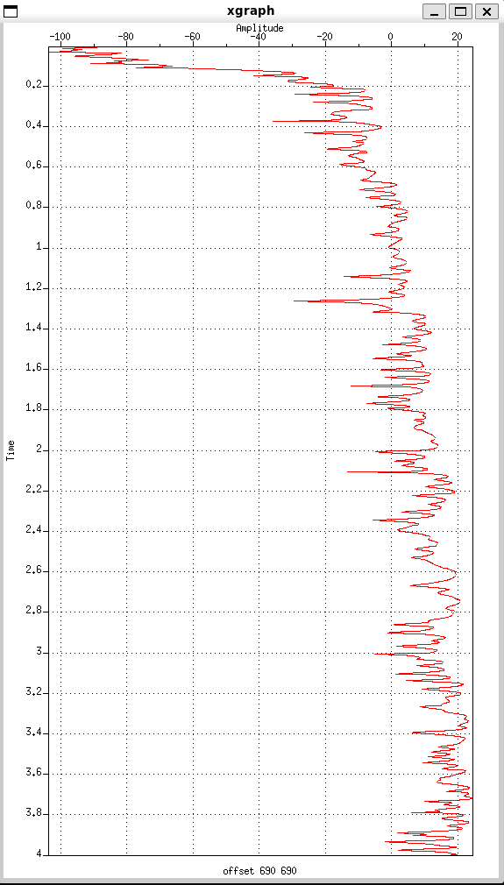
Fig. 7 – Wiggle Plot of seismic Data after AGC(0.750 s) and t^{p} (p = 1.5) | Fig. 8 – Attenuation of amplitude with time colormap diagram after AGC (0.750 s) and t^{p} (p = 1.5) | Fig. 9 – Attenuation of amplitude with time line plot after AGC (0.750 s) and t^{p} (p = 1.5)
Lastly, we have tried to apply gain and normalize the data using 1/rms approach, the results are as shown below:
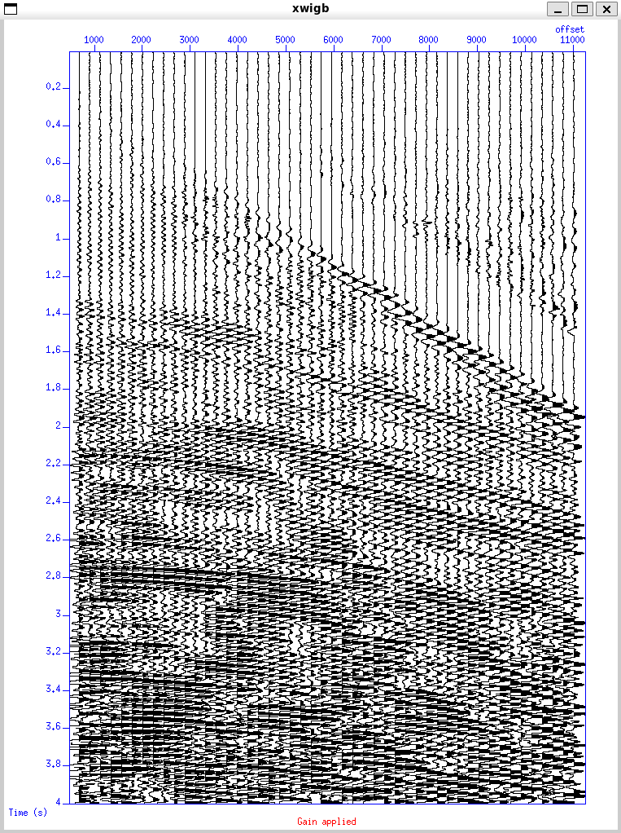 | 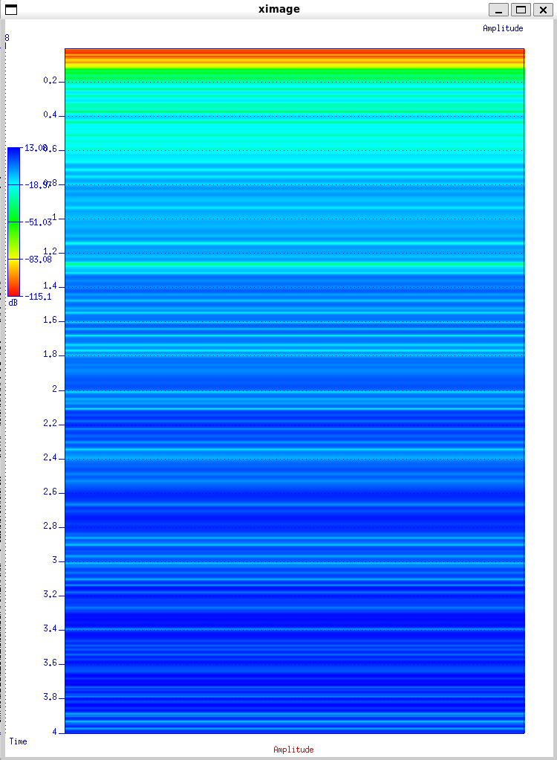 | 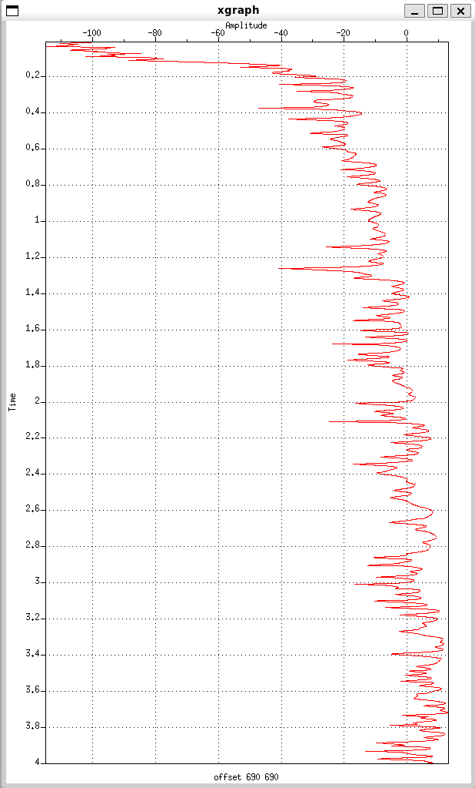
Fig. 10 – Wiggle Plot of seismic Data after AGC(0.750 s), t^{p} (p = 1.5) and 1/rms | Fig. 11 – Attenuation of amplitude with time colormap diagram after AGC (0.750 s), t^{p} (p = 1.5) and 1/rms | Fig. 12 – Attenuation of amplitude with time line plot after AGC (0.750 s) and t^{p} (p = 1.5) and 1/rms
- Frequency Filtering:
In this kind of filtering, the amplitude spectra is calculated using the fourier transform of the time series seismic data to convert it into frequency domain. Thereafter a cut-off frequencies are applied to cut the desired frequency and dump the frequency related to noise data. The time series data and the amplitude spectra is shown below:
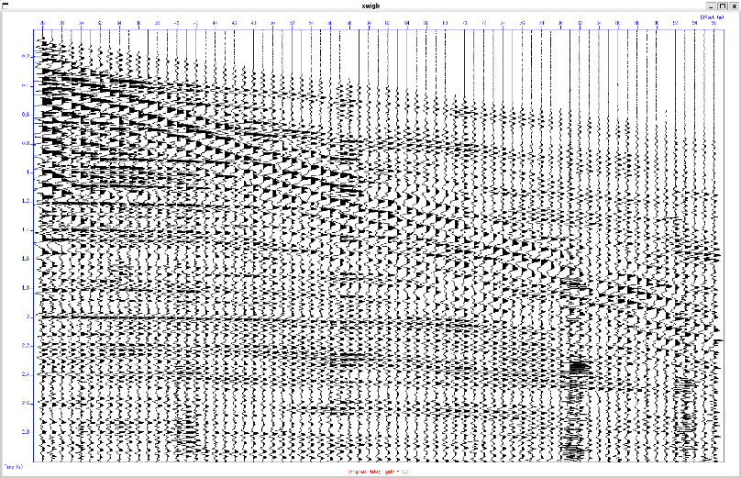 | 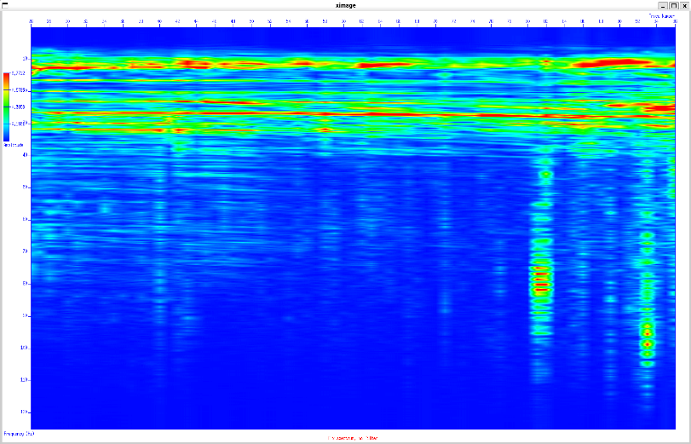
Fig. 11 – Wiggle plot of seismic data (time vs offset) | Fig. 12 – Fourier amplitude spectrum of the seismic data
Here as we can see that most of the data is concentrated in the region between 5 Hz to 45 Hz. So we will use a Ormsby filter to cut the desired region in the plot to get rid off from the noise in the data. The Ormsby filter uses 4 frequency values to apply a trapezoidal filter. We have assigned these frequency values as 5,8,35,45. The output is shown below:

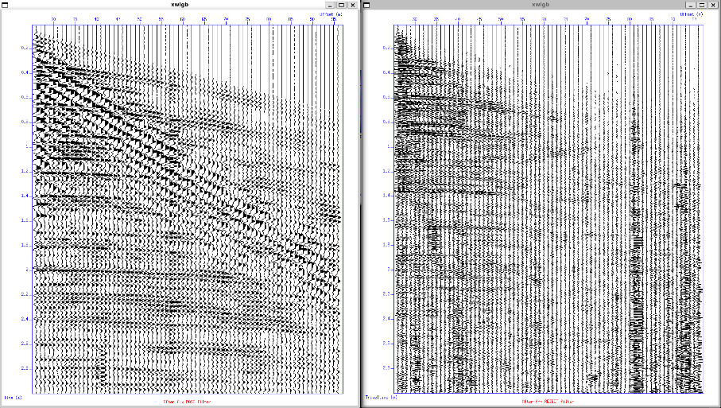 |  | 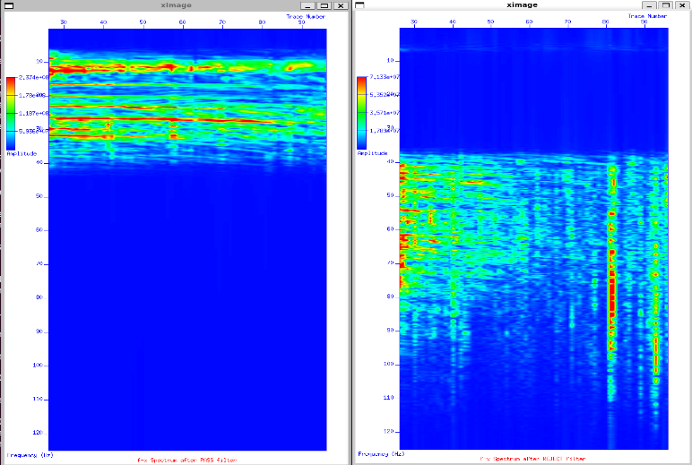 |  | 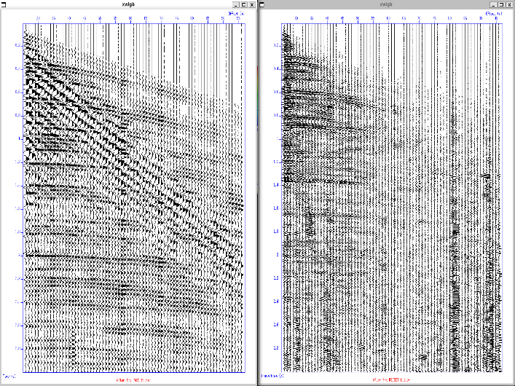 |  | 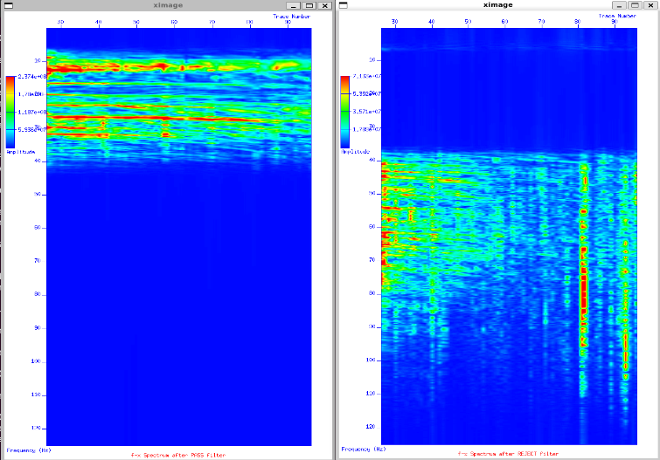
Fig. 13 – Wiggle plot after application of Band pass filter in freq. domain | Fig. 14 – Selected band/ Pass band region |  | Fig. 15 – Band rejected time domain data |  | Fig. 16 – Band rejected frequencies
- Fan filter:
The given slopes in for the application of the fan filter are -0.01,0,0.005,0.01.
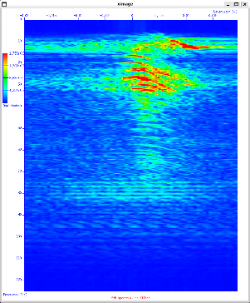 | 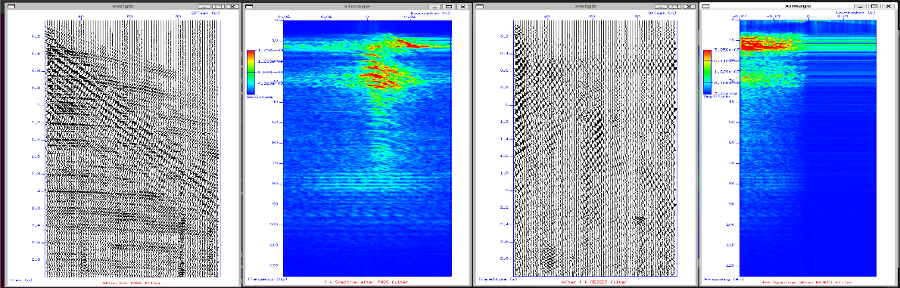 | 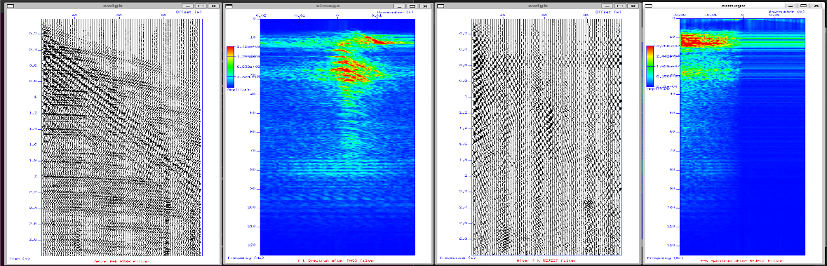 | 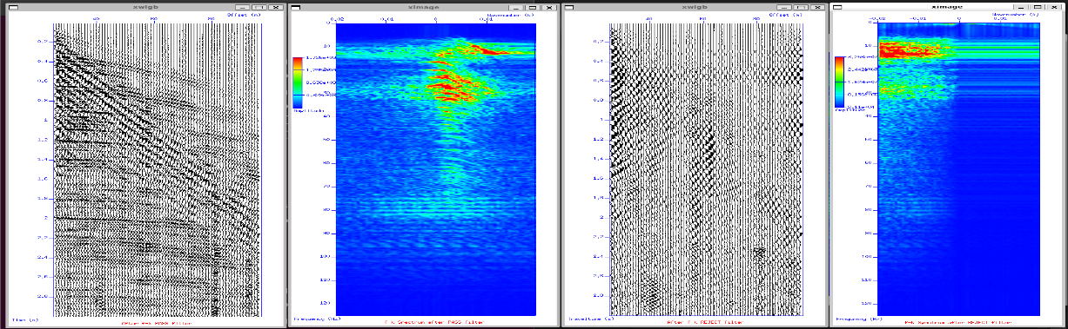 | 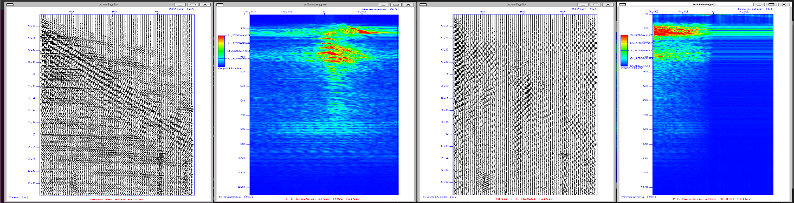
Fig. 17 – fk spectrum (no filter) | Fig. 18 – wiggle plot after band pass filter applied | Fig. 19 – Band passed fk spectrum | Fig. 20 – Rejected amplitudes | Fig. 21 – Rejected spectrum
- Velocity Analysis:
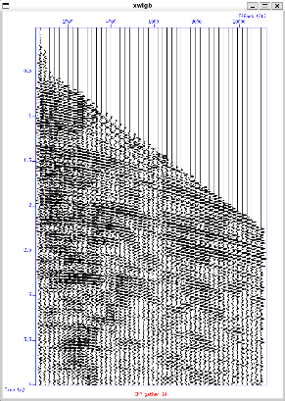 | 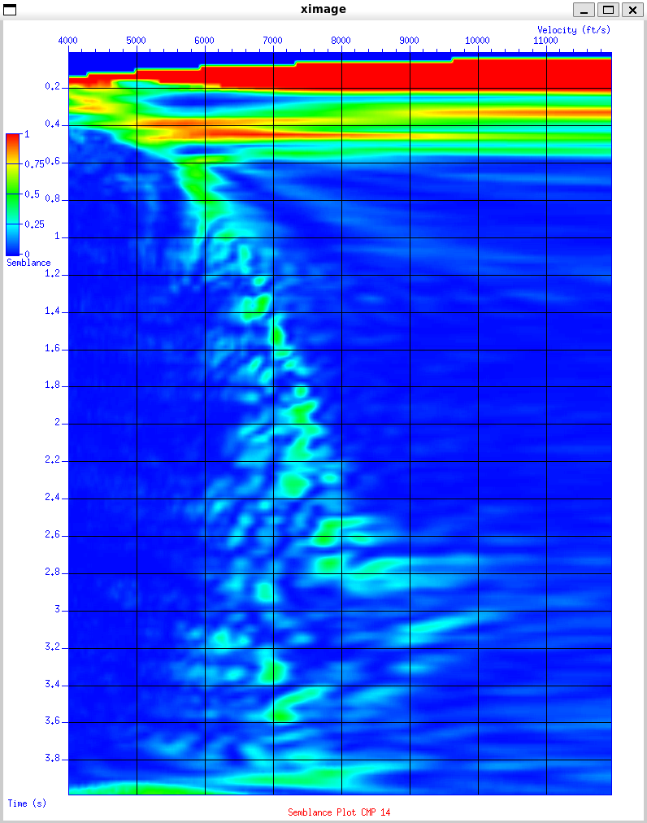
Fig. 22 – CMP gather for CMP-14 | Fig. 23 – Semblance Plot for CMP 14
After velocity picking the results are obtained as:
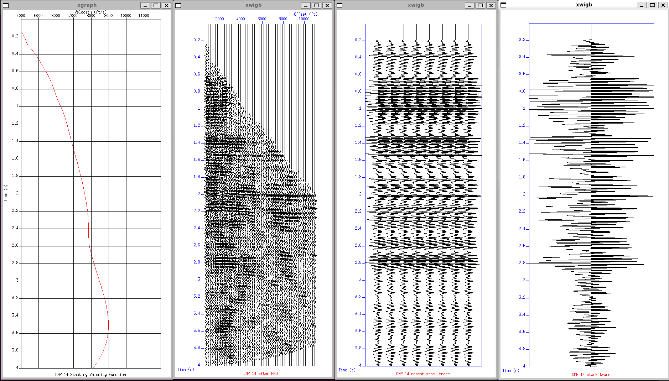 | 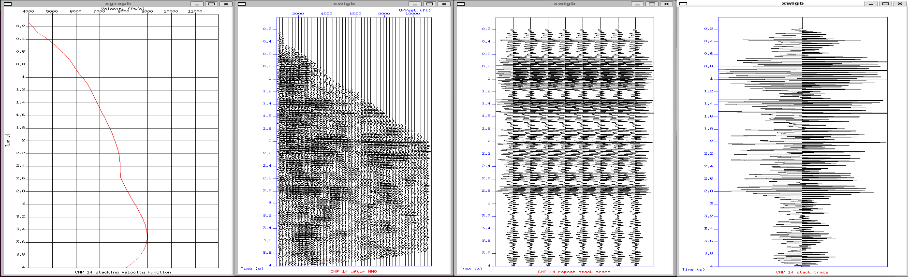 |  | 
Fig. 24 – Velocity variation with time | Fig. 25 – NMO corrected gather using velocities obtained from Semblance picking | Fig. 26 – CMP 14 Gathers after NMO | Fig. 27 – CMP 14 stacked data

